**User Manual for Simple Calculators and Interest Calculator**

For the regular calculator, the users choose the number on the keyboard relative to 0 – 9. The   
"+" is the addition button, the "-" button is the subtraction button, the "*" is the multiplication and the "/" is the division. The program calculates when you choose the "=" button. After clearing out the previous calculation, the new data is entered and stored into memory.

For the Interest calculator, the user will input the rate amount in dollars, the length of time in years and the interest rate. The calculate button will generate the results. There is a clear function to wipe out the results and start again. Entering a negative number simulates a loan end payment result. Per the requirements, there are two graphics included, although I was not able to get them to perform exactly as first envisioned (which would have been to show at the top of two separate screens). The pictures module window may be partially hidden behind the main interest calculator. I also created the graphics as a separate module to better show the process.

**Further research and reference**

These books provided additional research options. Although the underlaying code may not be Python.

Teach Yourself Visually Python. Guy Hart Davis, Ted Hart Davis. John Wiley and Sons, 2022

This book was helpful in looking at error codes, importing modules and sample snippets of non-Tkinter programs

Tkinter GUI Programming by Example, by David Love, 2018 Pacts Publishing

This book gave several selections of Tkinter programs such as game simulations and adding widgets.

Retirement Planning for dummies, Matt Krantz, John Wiley and Songs 2020

This book provided some ideas for future retirement calculator programming as well as website examples (see the next two pages.

Vanguard's Retirement Nest Egg Calculator

<https://www.fidelity.com/calculators-tools/retirement-calculator/overview>

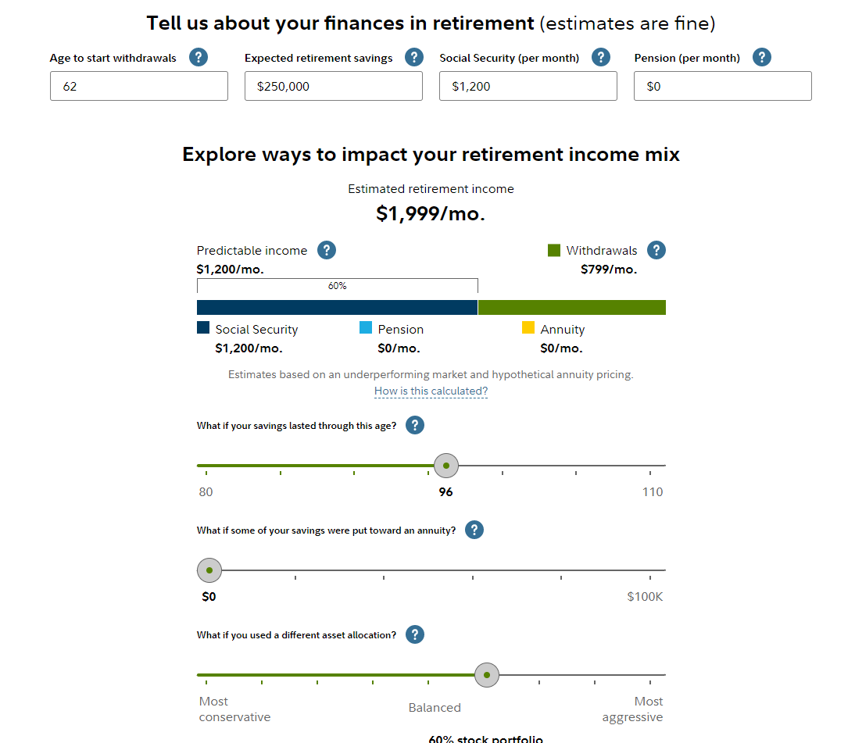

tdtrade

https://www.tdameritrade.com/retirement-planning/tools-and-calculators/retirement-income-calculator.html

